100mm Traffic Signal Light
USER MANUAL
1. Operating Specifications
Type | TSL100-R |  | TSL100-Y | TSL100-G
Size | ∅100 mm |  | ∅100 mm | ∅100 mm
Color | Red |  | Yellow | Green
Centre Luminous Intensity | ≥1000cd/m² |  | ≥1000cd/m² | ≥1000cd/m²
Semi-intensity Angle | Horizontal： | ≥30°
Semi-intensity Angle | Downward： | ≥30°
Operating voltage | 24VDC (100~240VAC optional)
Power consumption | ≤5W |  | ≤5W | ≤5.5W
Operating Temp. | －20 ~ +50ºC
Operating Life | >5 Year
2. Instructions for installation
1). Installing the shield：
Confirm whether the direction of the traffic signal light is horizontal or vertical.
Fix the aluminum shield to the traffic signal panel with four nails of M4*6 standards accordingly.
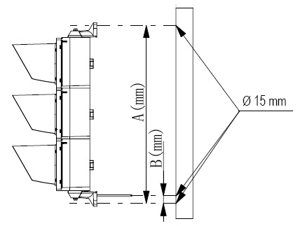
2). Hole position:

Step1: Drill three holes with Ø15 millimeter
Diameter (refer to the right installation diagram)

Step2: Height: The traffic core will be fixed to the
pole with 2.5M height (the distance between
the ground and the lowest end of pole)

Step3: The front of the traffic light must face
the middle of vehicle channels

Note: The direction of the traffic light can also be changed by adjusting the pole.

Hole positions:
 | One light | Two lights | Three lights
A (mm) | 290mm | 440mm | 590mm
B (mm) | 50mm

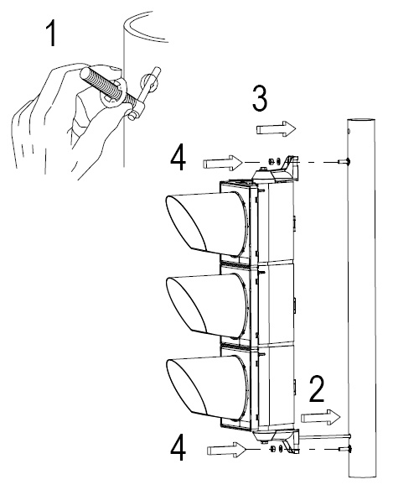
3). Mounting the traffic light to the pole

Step1: Insert the tip to the two holes and lock
up using a club gasket
Step2: Insert the cable
Step3: Fix the two brackets to the
M10 screws
Step4: Screw down the nut

4). Adjusting signal direction

Step1: Release the connecting nails between the
bracket and traffic light
Step2: Adjust the direction of the signal light
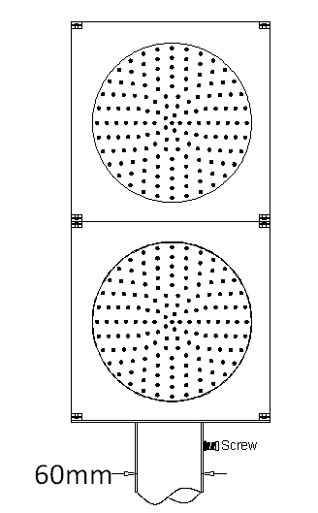
Step3: Confirm that the traffic light direction is right, and tighten the screws

3、Installation size requirement of base bracket:
The pole diameter must be less than 60mm

4、Connection diagram
Operating voltage： 24VDC (100~277VAC optional)

